**Irwan Syahputra ( BE-12 )**

**Create Account**

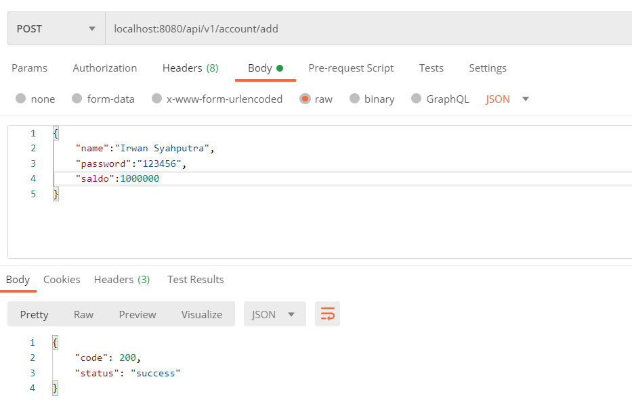

**Login**

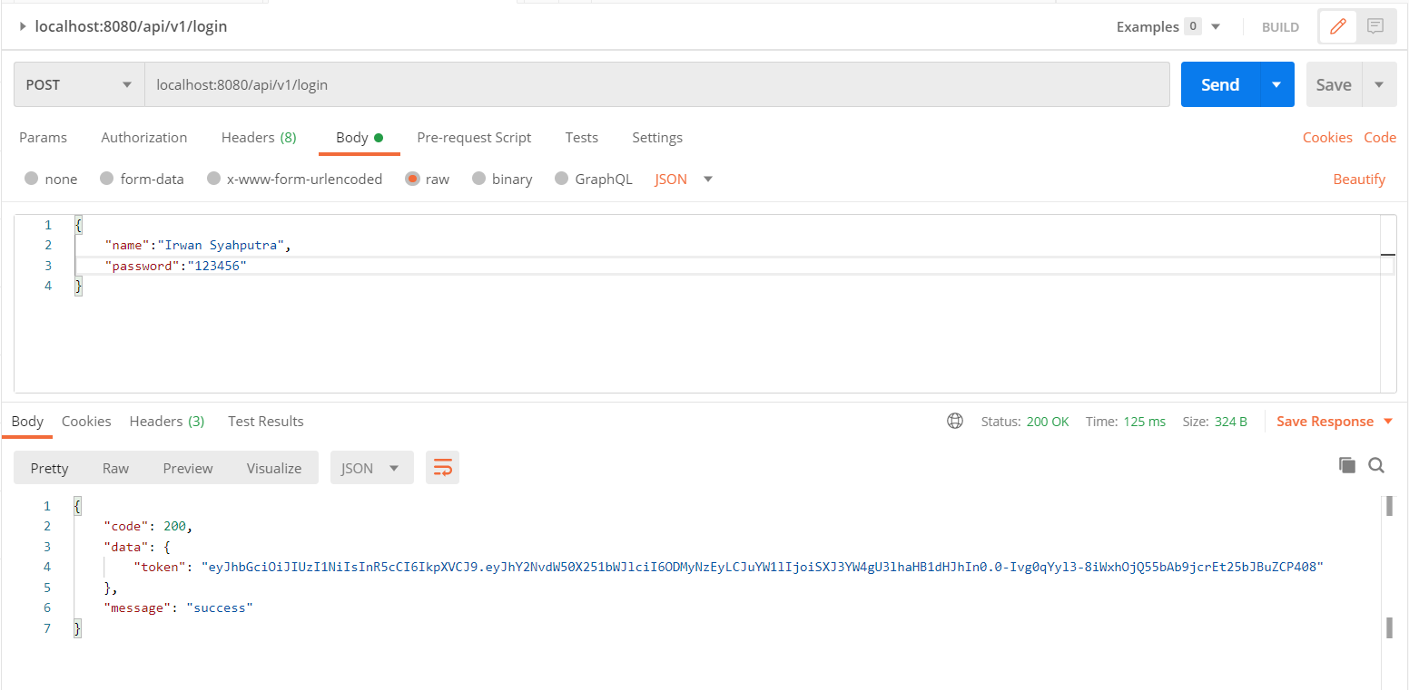

**Get Account Use Token Auth Login**

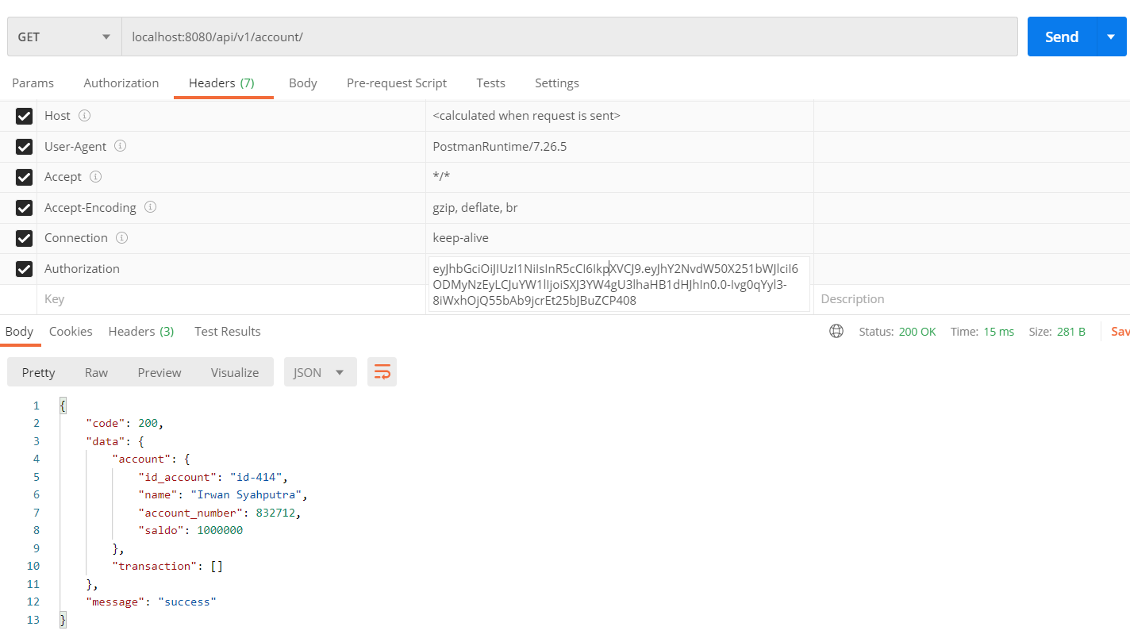

**Transfer Use Token Auth**

Data Account

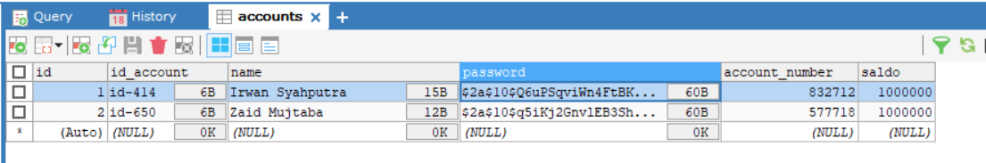

**Transfer From Irwan To Zaid Use account_number**

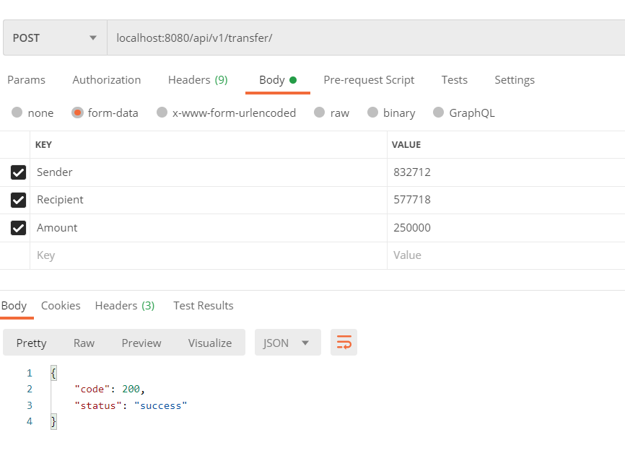

**Withdraw use Token Auth**

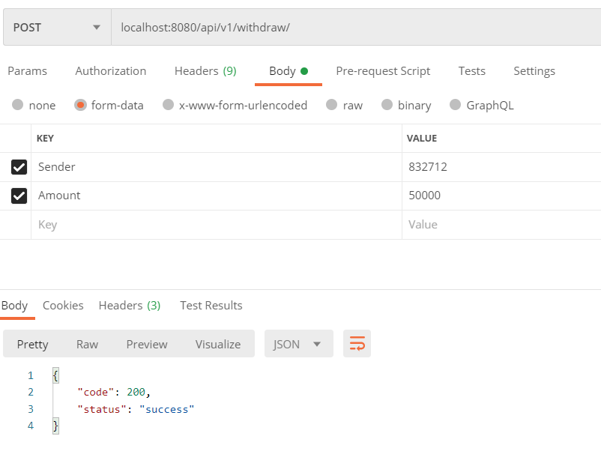

List Transactions

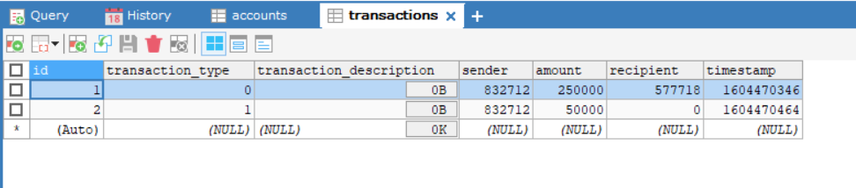

**Deposit**

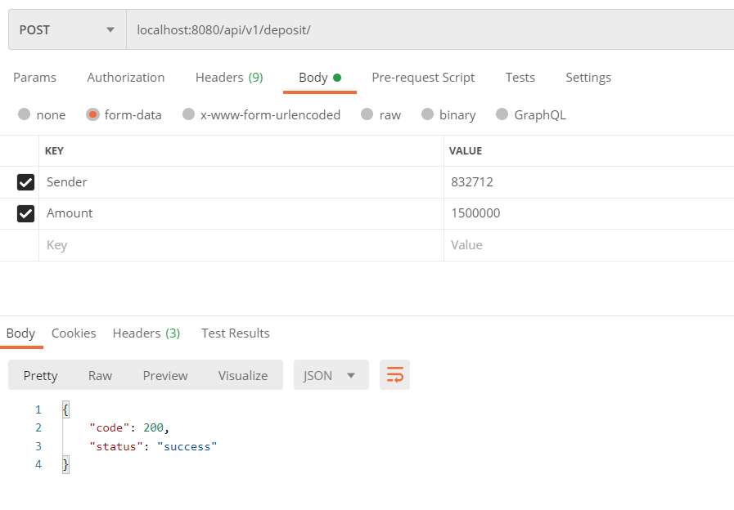

Table Transactions

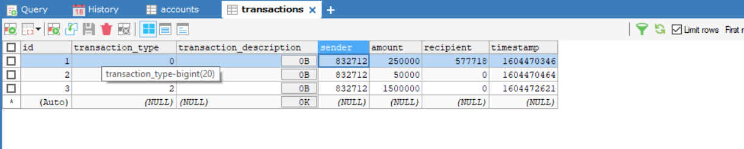

**Methode Interest**

Bunga yang ditambahkan sebesar 2% ke semua Account.

Function Interest di Models/bank.go:

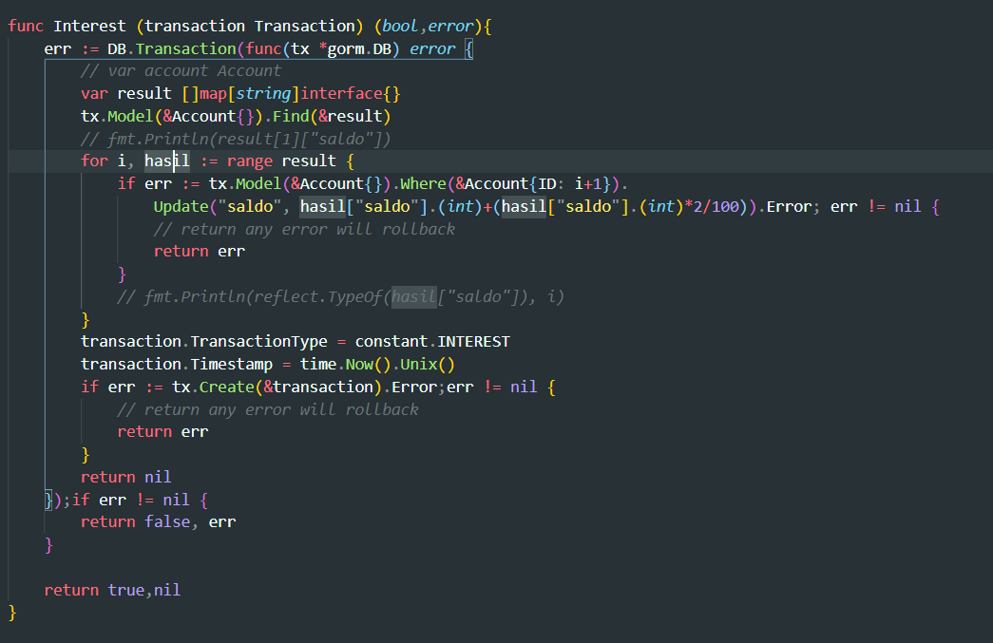

Function Interest di Controllers/controller.go

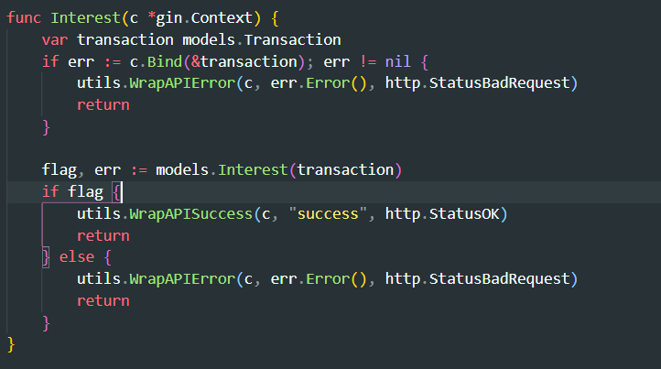

Postman:

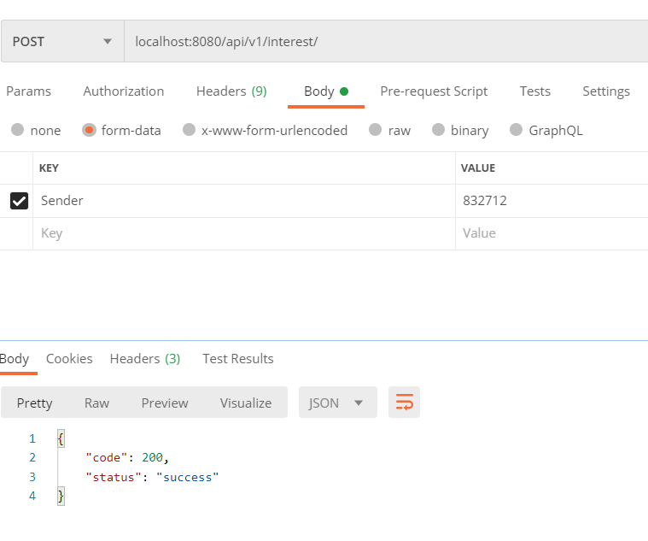

Tabel Transactions before execute interest api on postman

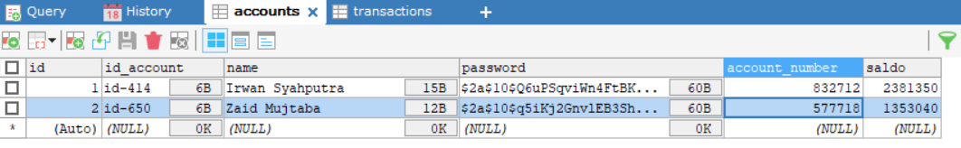

Tabel Transactions after execute interest api on postman

